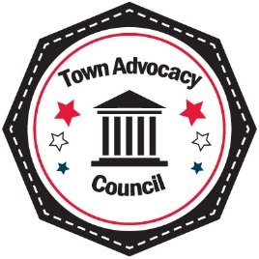
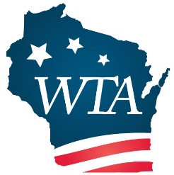
Wisconsin Towns Association &
Town Advocacy Council
Capitol Day, Thursday, March 30, 2023
Best Western Premier Park (formerly Inn on the Park)
22 S. Carroll Street, Madison, WI
8:00 a.m. Registration & Breakfast Sponsored by Scott Construction

8:45 a.m. Legislative Visit Preparation

10:15 a.m. Leave for Legislative Visits

10:30 a.m. Legislative Visits

12:00 p.m. Lunch

1:00 p.m. Debriefing of Legislative Visits
Legislative Guest Speakers

2:00 p.m. Adjourn

Your engagement with legislators is critical to the success of WTA’s legislative priorities. Thanks to the investment in TAC by over half of all towns, Capitol Day 2023 is now free to attend, including breakfast and lunch for all participants. Parking is available at the hotel on a first come first served basis for $4/hour. WTA has additionally reserved a block of rooms at the Best Western Premier Park hotel for those interested in arriving in Madison Wednesday night, March 29th. Rooms must be booked by March 15th to take advantage of the state rate of $90. Use the room block name “Wisconsin Towns Association” when making reservations. Space is limited.

Send registration to Wisconsin Towns Association, W7686 County Road MMM, Shawano, WI 54166 or email to sandy.wanta@wisctowns.com. Please register by March 15, 2023 so our staff can set up appointments with legislators as soon as possible.
---------------------------------------------------------------------------------------------------------------------
Registration Form for 2023 Capitol Day, Thursday, March 30, 2023

Town Click or tap here to enter text. | County Click or tap here to enter text.
Name Click or tap here to enter text. | Office/Position Click or tap here to enter text.
Phone Click or tap here to enter text. | Email Click or tap here to enter text.
Home Address (to set up legislator visits) Click or tap here to enter text.

