Name: Telephone: MailAddress: City/State/ Zip:

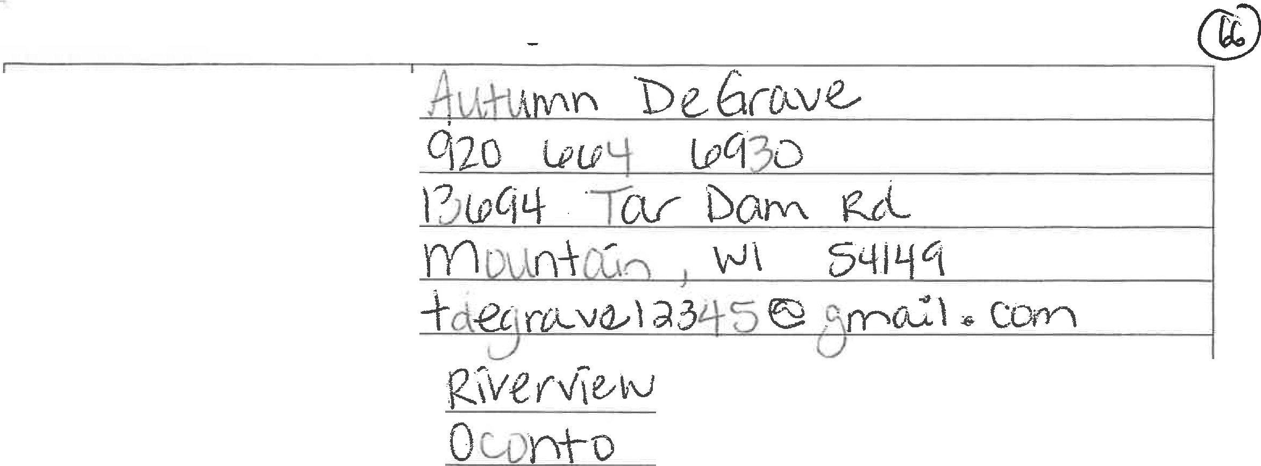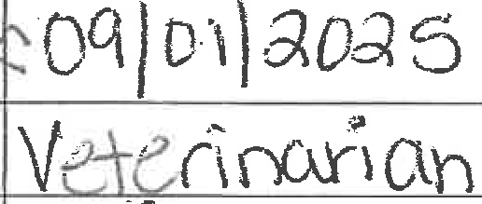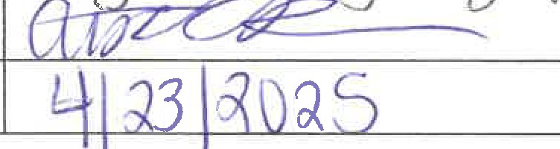

Email:

Residence Town/Village/City of: Residence County of:

Parents� Names:

Is either parent a town or village officer?

Nam� of 1::ligll School from which you are graduating in **2025?**

School or institution of higher education you plan to attend after Graduation?

Date of intended enrollment?

-

Career you plan to pursue?

Father:Chr\� �ro\.,ve.. Mother�ouu'- *De(;,rtA.Ve.*

Yes: --,-,-- If "yes" specify office held: _ No: "A

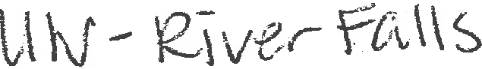

Hobbies or activities in high Y--��,\\:'�'., CrO�>ht;.-h:f j ,3-e�)f\c),,_, r\:)LA*J_* f"FA-, .

school of interest to you? , \ � • nef\C2 \I'"'\ \/ e(",

t,f

!---------�--�.,;..:..:-,,,=+-.::....=....;c....,;..,--:-----;�'----7'>;---'if--� ,,;; : : ;::; :_---,-\---i

Your signature:

Date:

Mail this completed form and your essay to the following address by May 23, 2025 Wisconsin Towns Association

W7686 County Road MMM Shawano, WI 54166-6086

* See back for Scholarship essay requirements *

\_.J

[\,

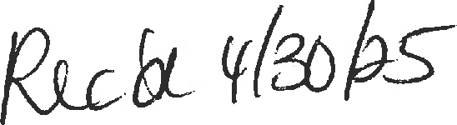



***Three Top Priorities To Enhance Quality of Life***

Quality of life is defined as a standard of health and happiness experienced by an individual or group (https://www.merriam-webster.com/dictionm::y/quality%20ofl/420life#:~:text=%3A%20oyerall%20enjoy ment%20of%20life%20%3A%20general%20well%2Dbeing ). It is subjective in nature and is dependent on how each individual or group identifies how to measure quality oflife. Three priorities that are often used to measure quality oflife that I feel the town of Riverview's officials should pursue are community health, economic development, and good governance.

The health of residents is critical to the success of any community. This includes residents' physical and emotional health. According to the Oconto county Community Health Assessment, the greatest health needs for county residents are mental health, alcohol & other drug abuse (AODA), and physical activity & nutrition

(https://[www.ocph.info/wp-content/uploads/Oconto-County-Community-Health-Assessment-2023-2026.p](http://www.ocph.info/wp-content/uploads/Oconto-County-Community-Health-Assessment-2023-2026.p) df). A leading factor of these aspects is residing in a rural community. This factor impacts access to services such as mental health, AODA care, or grocery stores, and socialization activities. Strategies that town officials could focus on to improve community health are improving access to food or health programs by inviting programs/agencies to be accessed at the town hall, creating a farmers market for residents to access fresh foods locally, and hosting and sharing event information for socialization events that focus on all age groups. As our community has a large tourism industry it will be essential to plan strategies for local residents that are not conflictual with peak tourism times/days.

A second priority for town officials to pursue is economic development. The local economy is at the mercy of tourism and, oftentimes, weather. For example, snowmobile season brings tourists to the area during winter but in seasons without a great deal of snow, the tourists do not come. Although the tourism industry is huge in the area, it is important to diversify the economy and dependence on this one industry (https://envisio.com/blog/strategic-plans-for-small-towns-considerations-and-strategies-for-success/ ).

Strategies for town officials to consider are providing incentives or personal invitation to draw businesses to the area that complement the skilled workforce of the residents who are often commuting to larger surrounding cities for work, and building on recreation activities to support year round tourism that is not dependent on snow. With improving the local economy it is hopeful that additional businesses and new residents will want to come to the area.

A third priority for town officials to prioritize is good governance. Governance is defined as the decision making process and follow through

(hrtps://michigantownships.org/wp-content/uploads//July-2007-Michigan-Township-News-Cover-Storv.p df). Some strategies for local town officials to have good governance are to have clear and multi-faceted communication with residents, to make sound decisions based on factual information and feedback from residents, and to implement decisions timely. Communication strategies need to include targeting all age groups of residents and in different ways. Examples include; events targeting young adults, and reaching residents via newsletter and social media platforms. Implementing decisions needs to be timely and not pushed off to a later time. This increases transparency and accountability to residents. These strategies for good governance will help with overall resident engagement and trust, as well as accountability.

# Insummary. three prioritieg I feel that my local town officials should focus on are community health, economic .develo�and good governance. The impact of these prioritie� will help to improve the overall quality oflife of residents, and in tum,�rill help to encourage young adults to return to the area after college, as well as encourage new businesses and new residents.

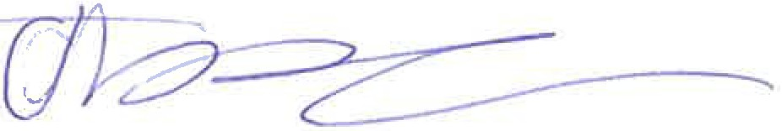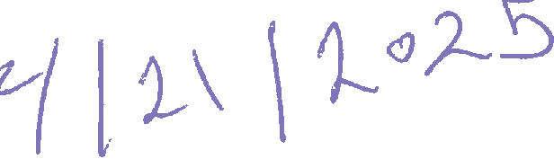

Works Cited

Healthy Oconto County. **"Community Health Neeq:; Asst** ssment.tt ***OCPH,***

[https://www.ocph.info/wp-content/uploads/Oconto--County-Community-Health-Assessmenta2023](http://www.ocph.info/wp-content/uploads/Oconto--County-Community-Health-Assessmenta2023)

-2026�pdf.

King, Mary. "Strategic Plan For Small Towns.'�*Enviso,*

https://envisip.qomlblog/sn,tegi�pijms-fC)f-Slnall-towns-considerations-and-strategies-for-suooes

*sl.*

"QUALITY OF LIFE Definition & Meaning." *Merriam-Webster,*

[https://www.merriam-webster.com/dictionary/quality°/420o£G/o20life.](http://www.merriam-webster.com/dictionary/quality)Accessed 21 Apri12025.

Stark, Nancy. "'Effective :jlurat Governance.ff *Michigan townships,*

https://michigantownships.org/wp--content/uploads//Ju!y-2007-Michigan-Townshlp-News-Cover­ Story.pdf.